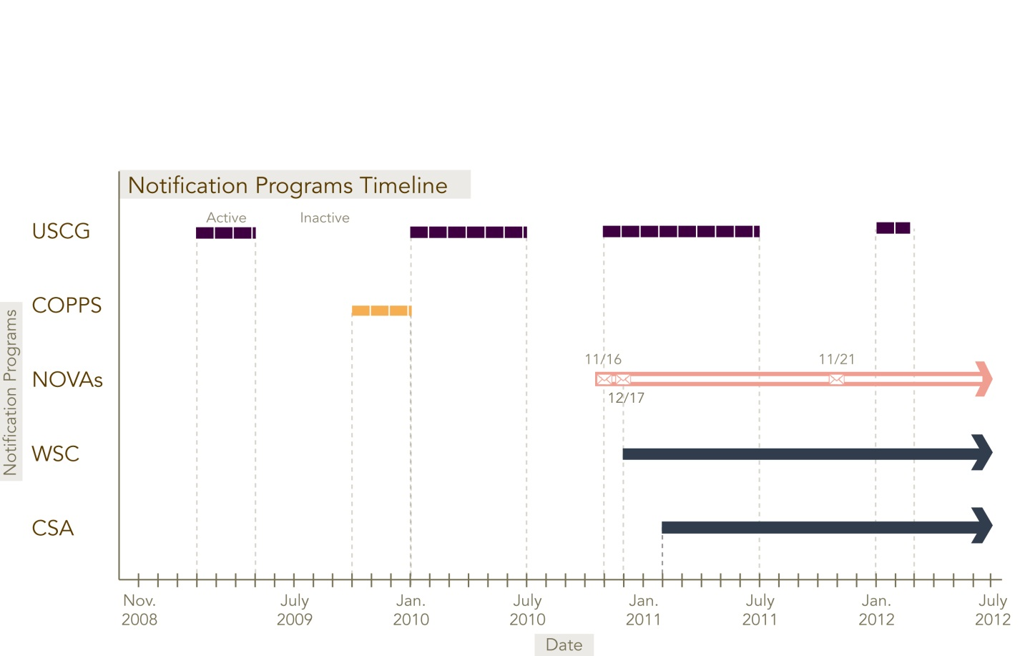

COPPS = warning or notification letters sent by office of law enforcement

USCG = at-sea hailings by the the CG

NOVAs = notices of violations accompanied by fines

WSC = monthly summary of vessel operations for those represented by the World Shipping Council

CSA = monthly summary of vessel operations for those represented by the Chamber of Shipping of America